> **## AGYEMANG ERIC**

**> ## MAT 450 HOMEWORK 7**

> library(survey)

> syc$numarr[syc$numarr==99] <- NA

> syc$probtn[syc$probtn==99] <- NA

> syc$corrinst[syc$corrinst==99] <- NA

> syc$agefirst[syc$agefirst==99] <- NA

> syc$livewith[syc$livewith==99] <- NA

> syc$age[syc$age==99] <- NA

> syc$crimtype[syc$crimtype==99] <- NA

> syc$sex[syc$sex==99] <- NA

> syc<-na.omit(syc)

>

> **##QUESTION 13**

**> ##ESTIMATING WITH WEIGHT##**

> stat_stra<- svydesign(id=~1, strata=~stratum, weights =~finalwt, data=syc)

>

**> ##The Histogram**

> svyhist(~syc$agefirst,stat_stra)

>

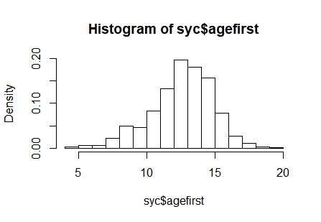

**##The average age of first arrest**

> svymean(~syc$agefirst,stat_stra)

mean SE

syc$agefirst 13.086 0.0496

>

> **##The median and 25th percentile**

> svyquantile(~agefirst, stat_stra, c(.25,0.5), ci=TRUE)

$quantiles

0.25 0.5

agefirst 12 13

$CIs

, , agefirst

0.25 0.5

(lower 12 13

upper) 12 13

**> #Therefore the required quantities are: Mean = 13.086,**

**Median = 13, 25th percentile = 12**

>

**> ##ESTIMATING WITHOUT WEIGHT**

> stat_stra1<- svydesign(id=~1, strata=~stratum, data=syc)

> **##The Histogram**

> svyhist(~syc$agefirst,stat_stra1)

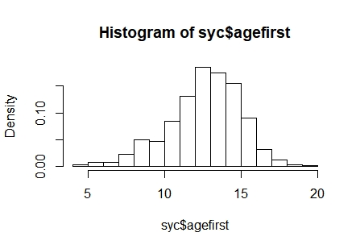

> **##The average age of first arrest**

> svymean(~syc$agefirst,stat_stra1)

mean SE

syc$agefirst 13.105 0.0464

>

**> ##The median and 25th percentile**

> svyquantile(~agefirst, stat_stra1, c(.25,0.5), ci=TRUE)

$quantiles

0.25 0.5

agefirst 12 13

$CIs

, , agefirst

0.25 0.5

(lower 12 13

upper) 12 13

> **## The quantities are Mean = 13.01, Median = 13,**

**25th percentile = 12**

>

> **##The weights change the estimates very little so there is no much difference between estimating with weight and estimating without weights.**

>

> **##QUESTION 14**

**> #a)**

> #young<-syc[syc$age <= "14",]

> young=ifelse(syc$age<=14,1,0)

>

> ##############proportion#####################

> svymean(~young,stat_stra)

mean SE

young 0.1237 0.0085

> confint(svymean(~young,stat_stra))

2.5 % 97.5 %

young 0.1070824 0.1403186

>

**> #b)**

> violence=ifelse(syc$crimtype ==1, 1 ,0)

> ##############proportion#####################

> svymean(~violence,stat_stra)

mean SE

violence 0.44707 0.0114

> confint(svymean(~violence,stat_stra))

2.5 % 97.5 %

violence 0.4246664 0.469479

>

**> #c)**

> live=ifelse(syc$livewith ==3,1,0)

>

> ##############proportion#####################

> svymean(~live,stat_stra)

mean SE

live 0.29631 0.0103

> confint(svymean(~live,stat_stra))

2.5 % 97.5 %

live 0.2760864 0.3165312

>

**> #d)**

> male=ifelse(syc$sex== 1,1,0)

>

> ##############proportion#####################

> svymean(~male,stat_stra)

mean SE

male 0.93379 0.0055

> confint(svymean(~male,stat_stra))

2.5 % 97.5 %

male 0.9230448 0.9445423

>

**> #e)**

> hispanic=ifelse(syc$ethnicty ==1,1,0)

>

|  |
| --- |
| ##############proportion#############  > svymean(~hispanic,stat_stra)  mean SE  hispanic 0.18717 0.0087  > confint(svymean(~hispanic,stat_stra))  2.5 % 97.5 %  hispanic 0.1700871 0.2042552  >  **> #f)**  > single=ifelse(syc$livewith<=2,1,0)  >  > ##############proportion###########  > svymean(~single,stat_stra)  mean SE  single 0.54506 0.0115  > confint(svymean(~single,stat_stra))  2.5 % 97.5 %  single 0.5225757 0.5675375  >  **> #g)**  > drug=ifelse(syc$everdrug==1,1,0)  >  > ##############proportion###########  > svymean(~drug,stat_stra)  mean SE  drug 0.82415 0.0091  > confint(svymean(~drug,stat_stra))  2.5 % 97.5 %  drug 0.8063159 0.8419858 |
|  |
| |  | | --- | | > | |